Sitecore Hackathon Website Build for Single Page Application

We are using Sitecore 9.3 – and .Net Framework 4.7.2

**Introduction**

Our current version of the Sitecore Hackathon Web building is build on responsive and latest front end technology . We are following helix architecture principle to build the website .

In this document I shall try to explain the best features our site using screen shot of recent development.

**Business Requirement**

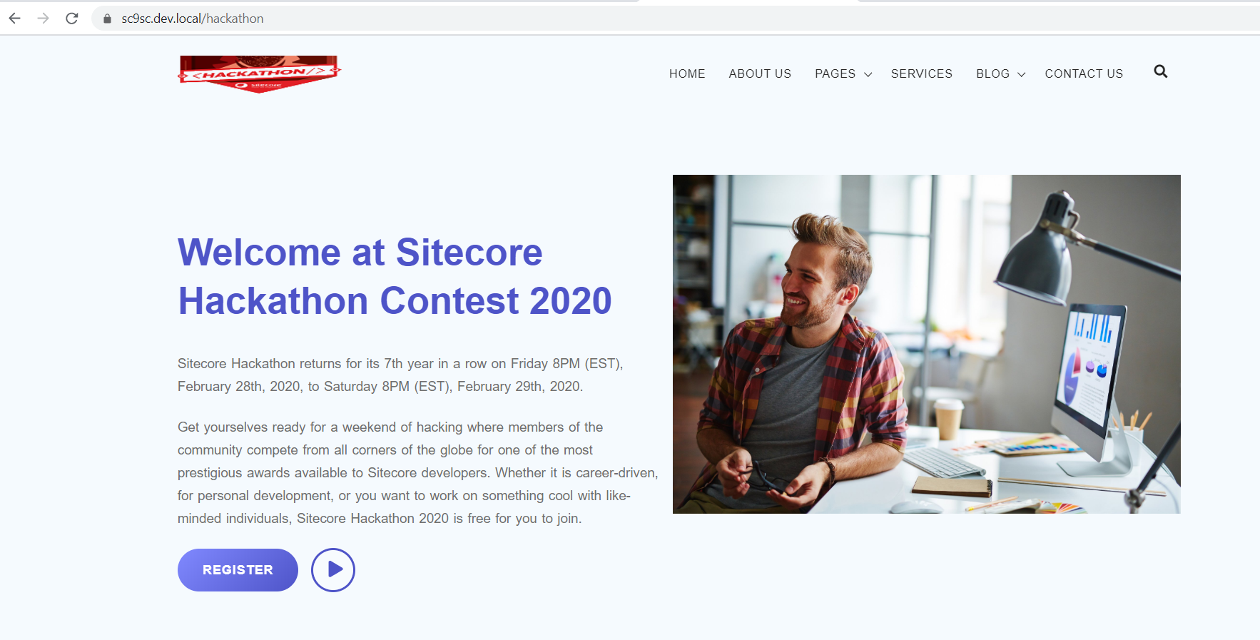

On the click of the play button will load the Hackaton video from youtube

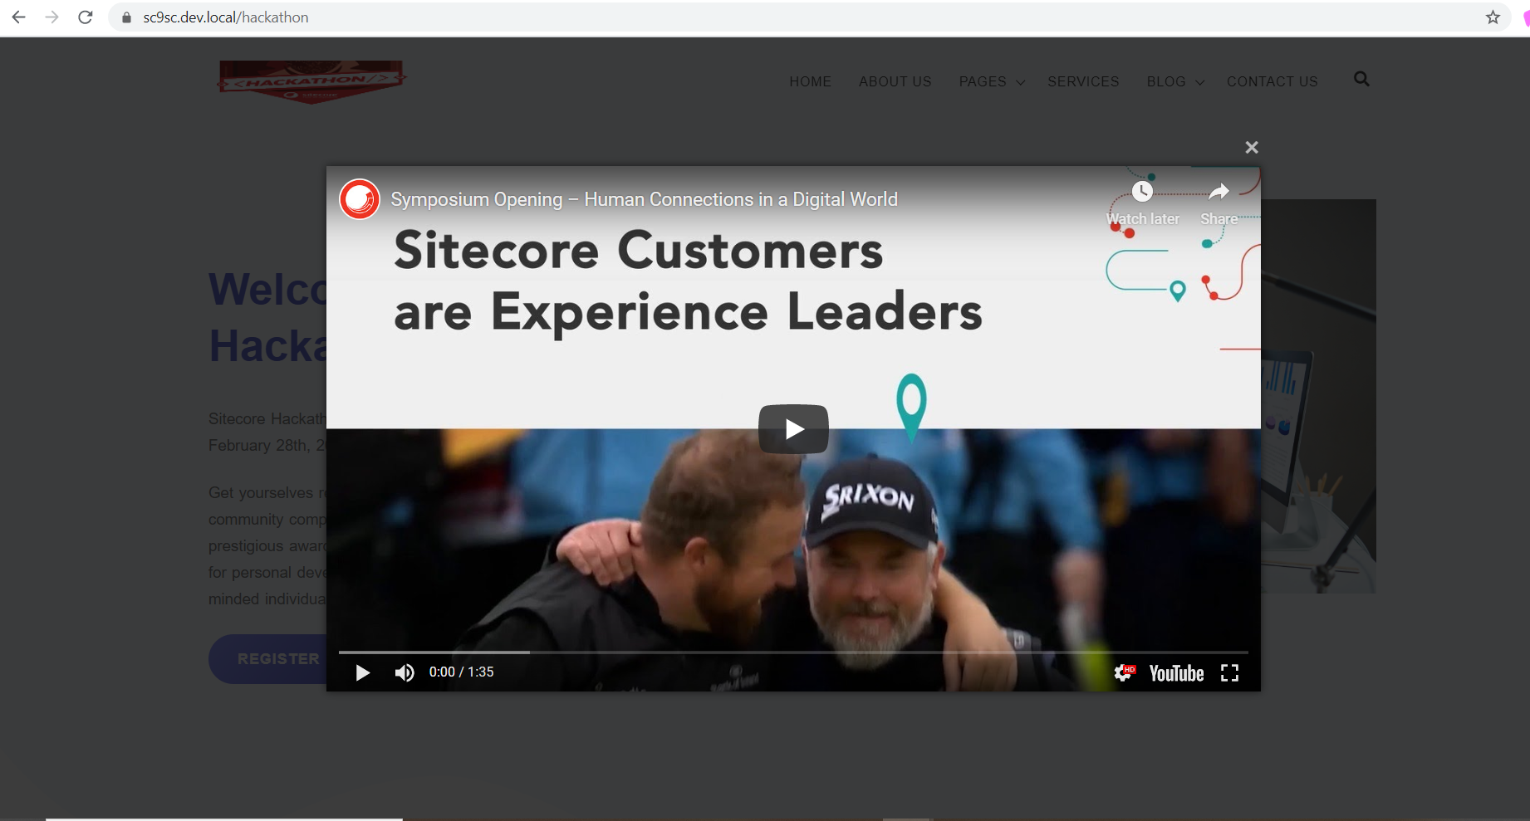

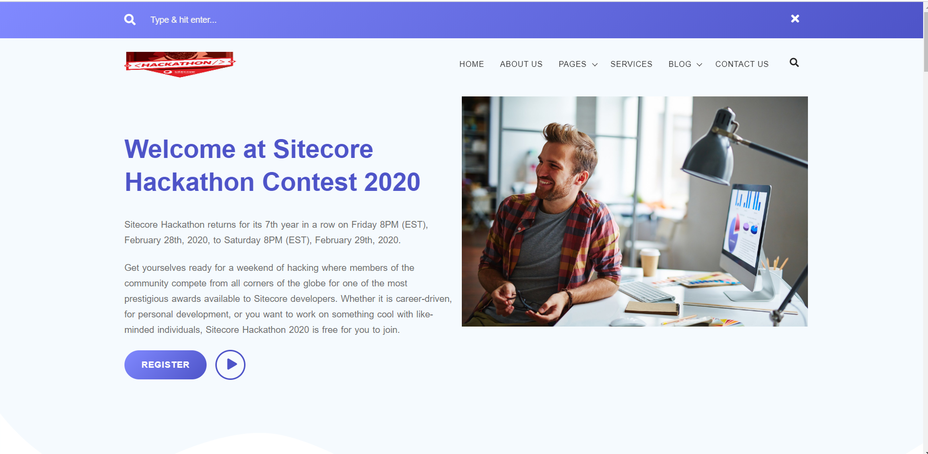

* The above search part functionality is not implemented .

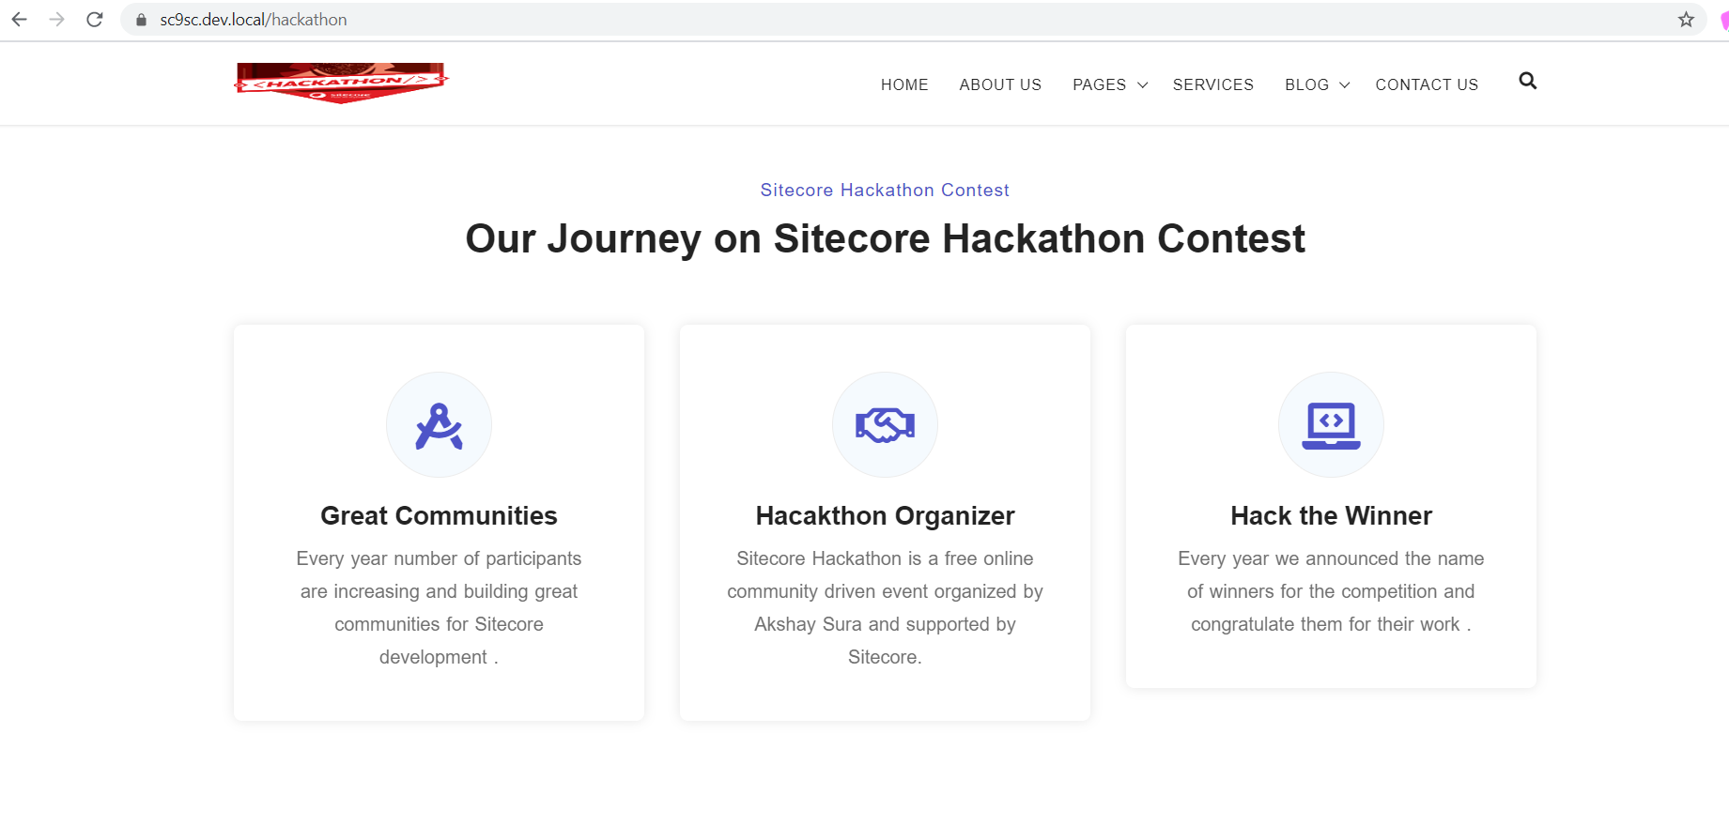

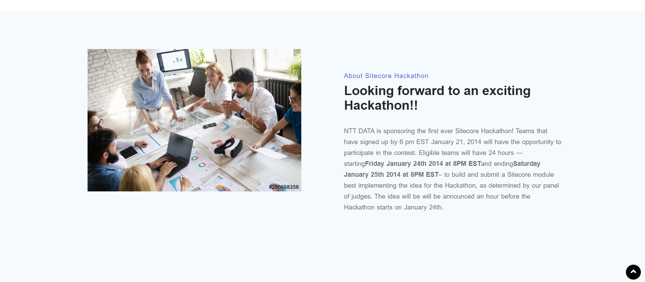

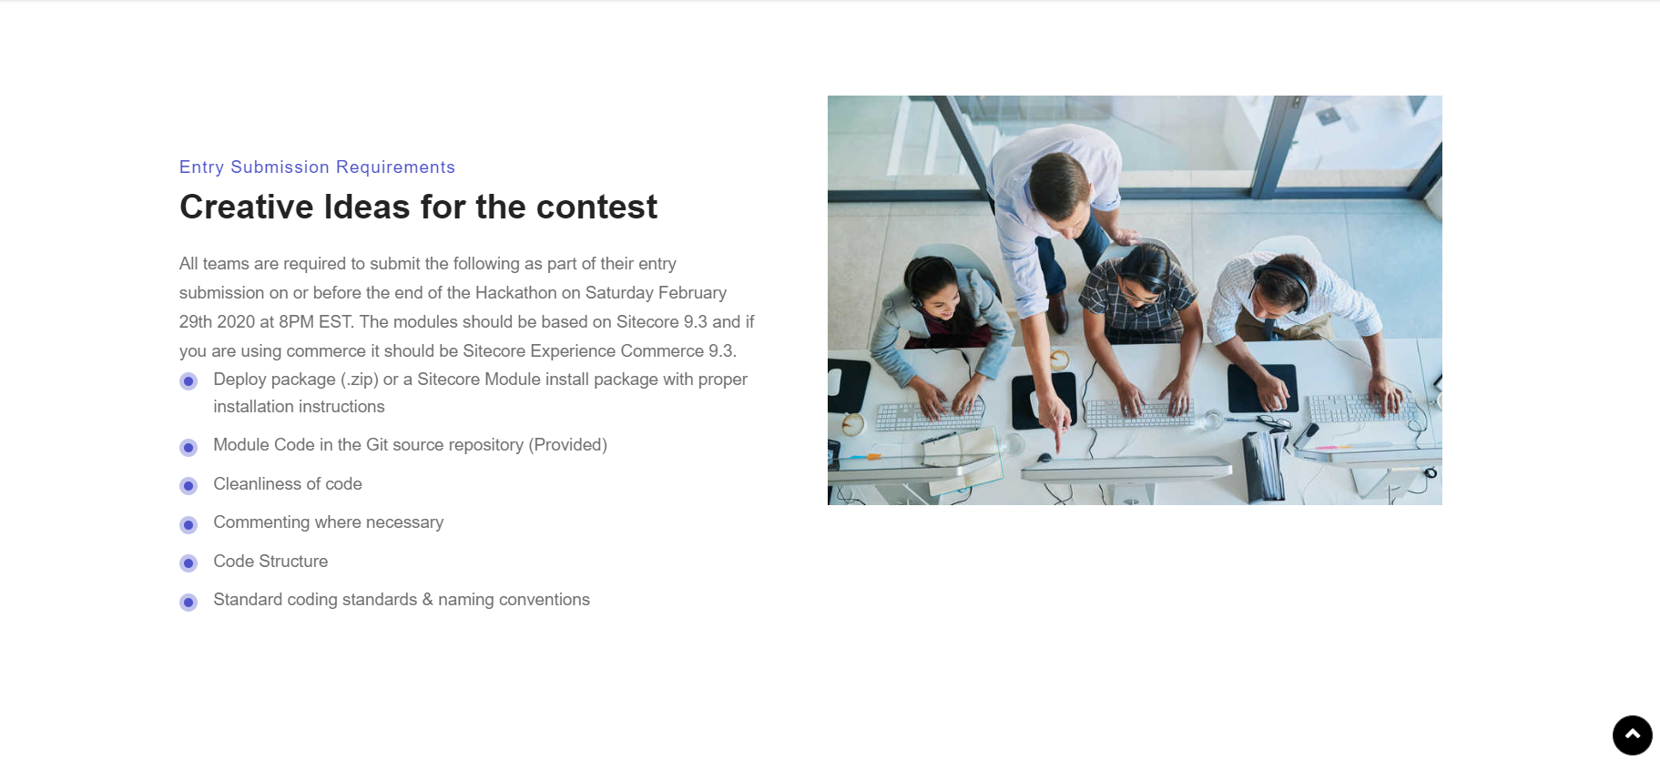

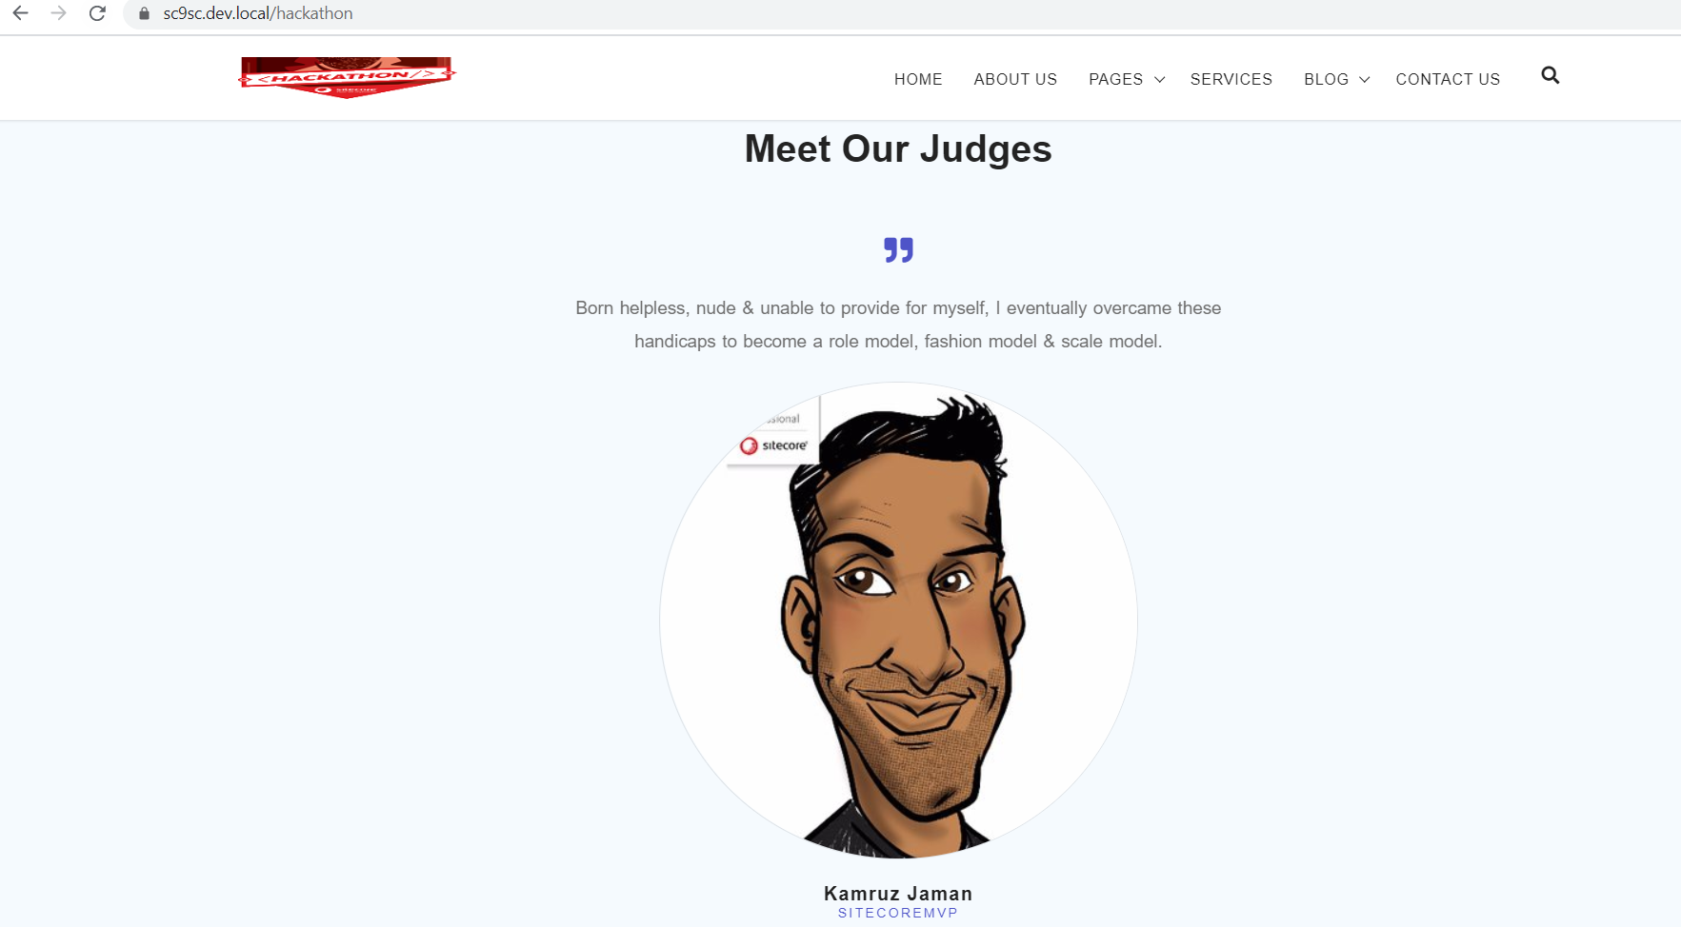

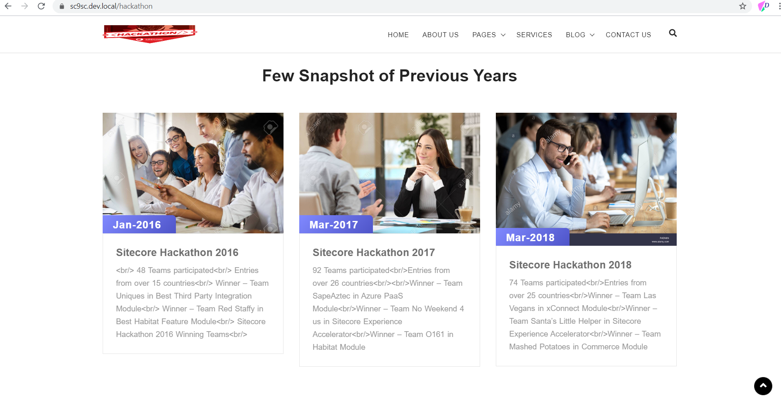



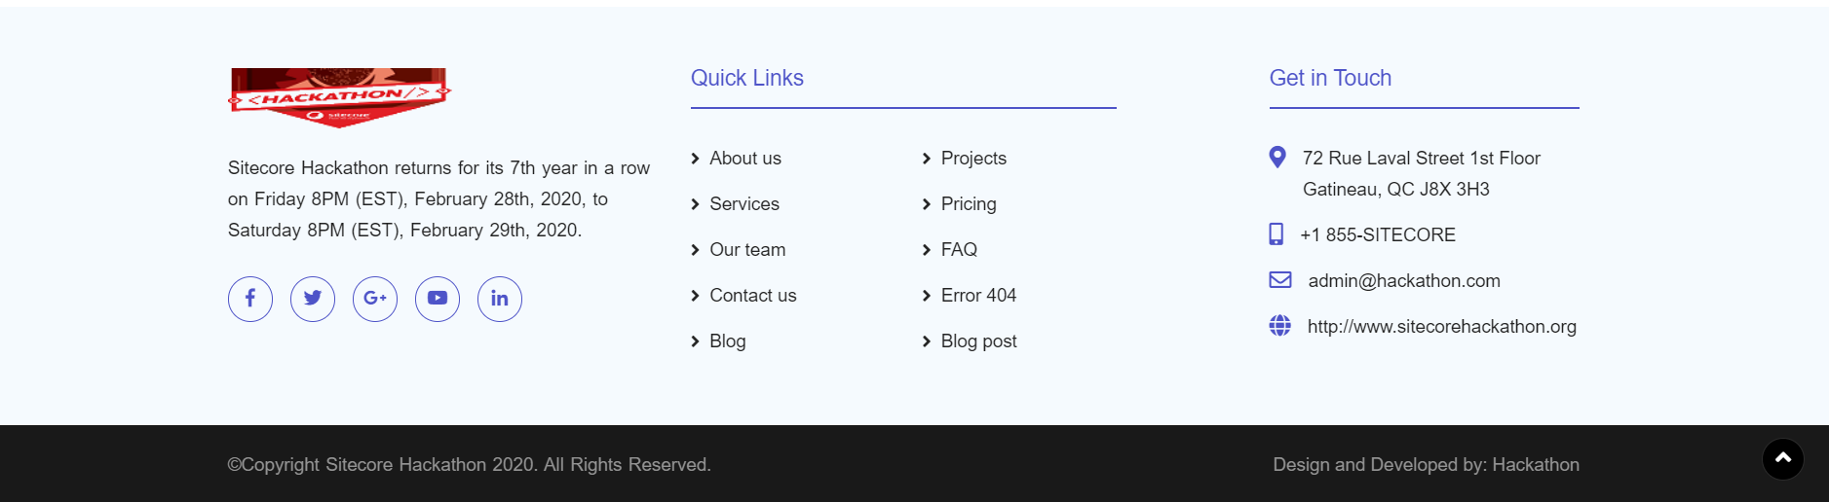

**Technical Summary**

To make the simplicity of content author and user I have created few component and also keep their placeholder name easy so that the content author feel comfortable to maintaining the website without any extra effort .

I have try to create some components based on the requirement and Html template design.

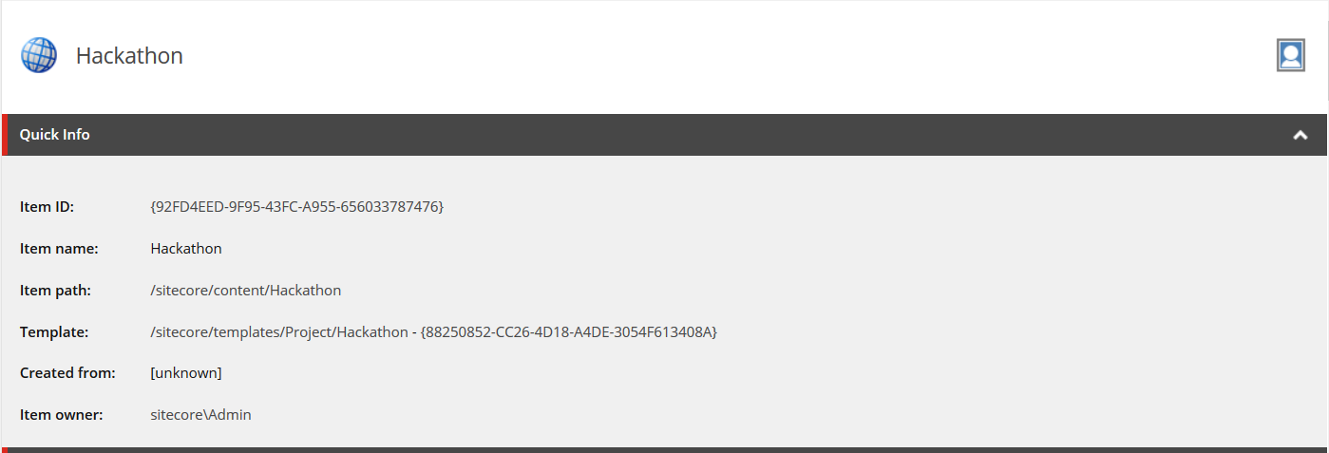

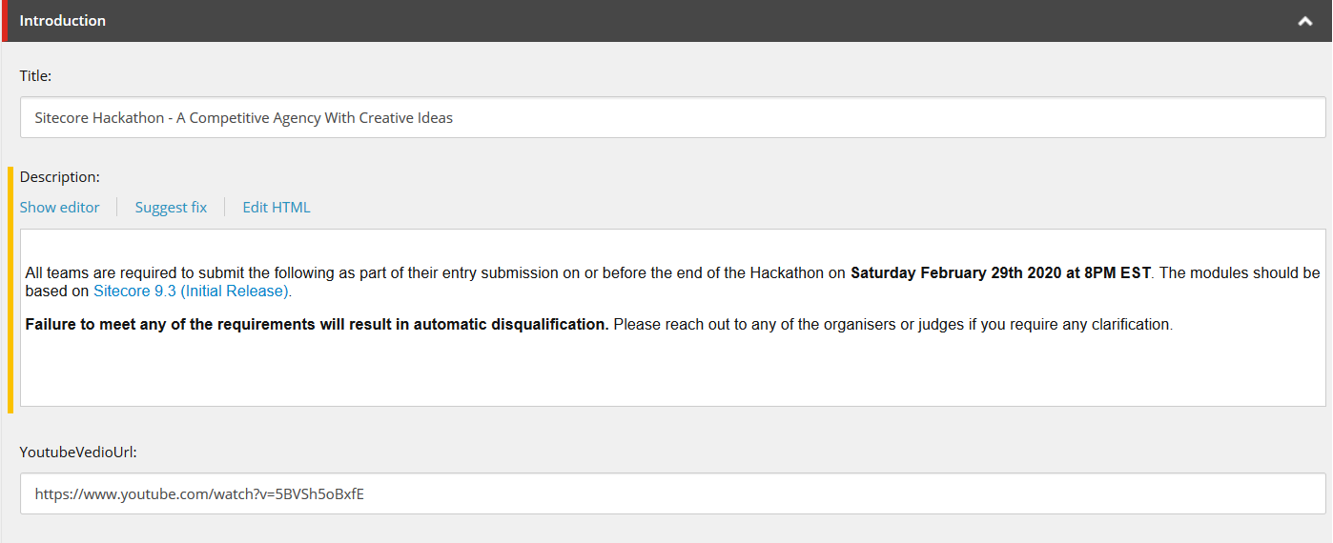

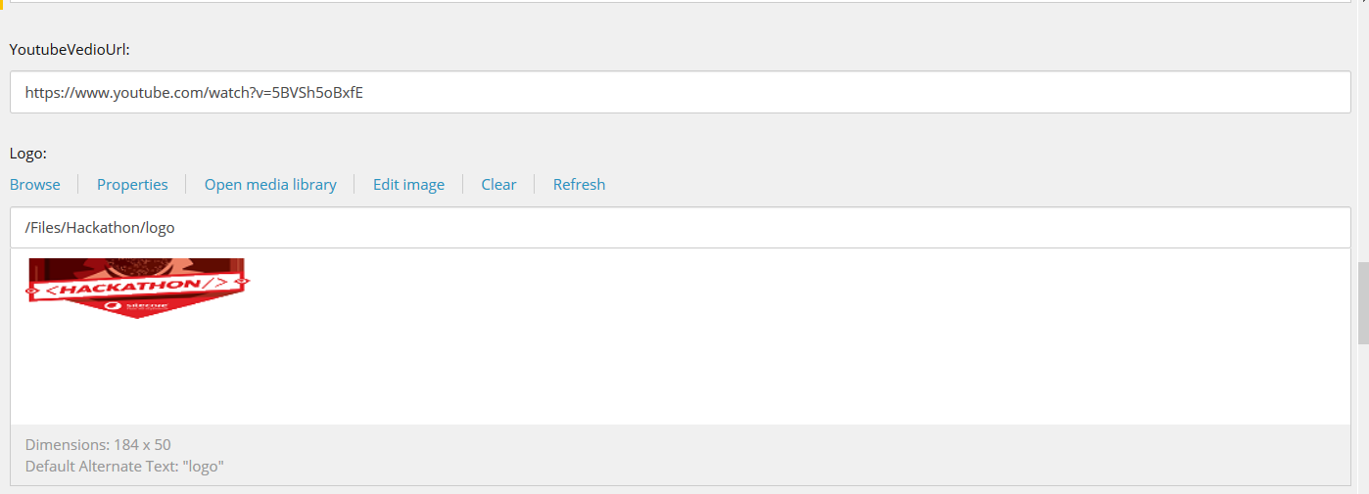

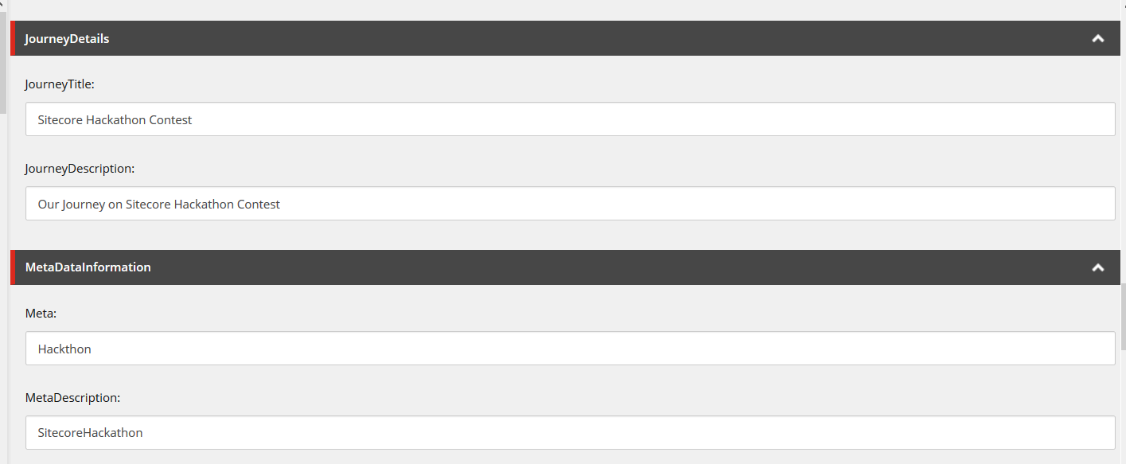

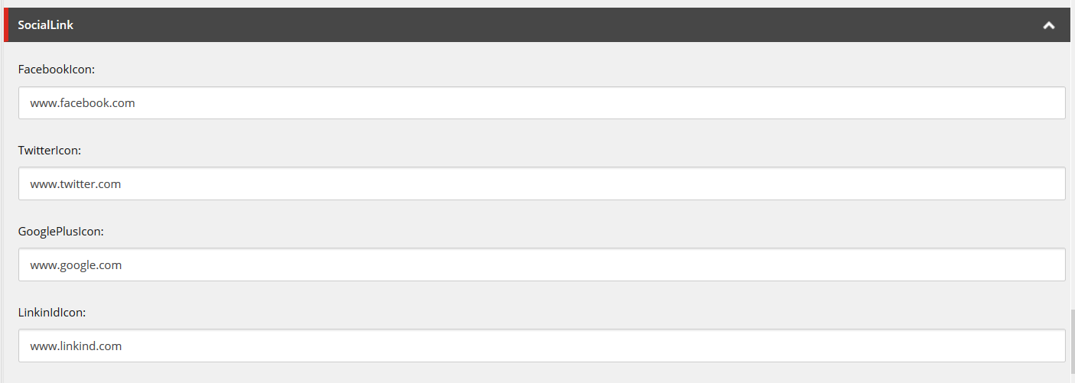

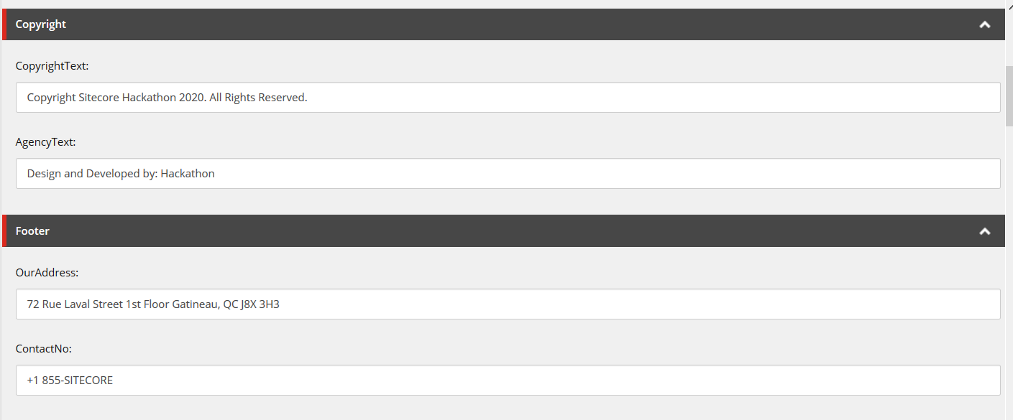

**Component List**

Menu : It is easy for content author to go in edit mode of CMS back office or in experience editor .

The placeholder name is same as it is like menu . There is data source from where the menu navigation items are picked up while running the website .

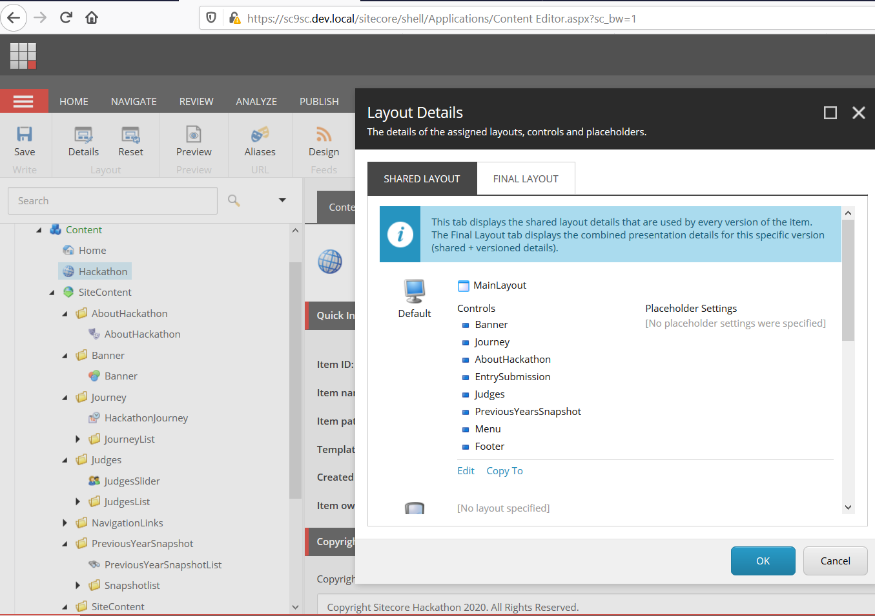

Banner : In our Html design it is good to show one good banner on the top of the website . So this is build , the placeholder name is banner

About Hackathon : In the current version of the website we have given a small details of the hackathon contest , so do build this component which will use the placeholder name content.

Entry Submission: Entry submission component is useful for the participants to know the details and description of the Hackathon contest , this is using placeholder name content.

Judges : Judges section is important to show their little information and how they are helping and encouraging the fellow developers to join the contest . This component is using same name like content .

Journey : Sitecore Hackathon is now more favourite to the fellow programmers , so in our website we have shown up their journey and how far it going . This component is using name journey-content.

Previous Year Snapshot : This component is developed for the best memory of all participants images . This component part will be describe the date year and number of winners of that year and little bit more information’s .

**Site Contents**

Site contents are using while rendering the components over the website . It is kept under a separate folder named site content and all of the item is created from multiple data template and stored in there .

Site Settings are used for stored imported information like Item Dictionary , Some third part API client secret key and other information .

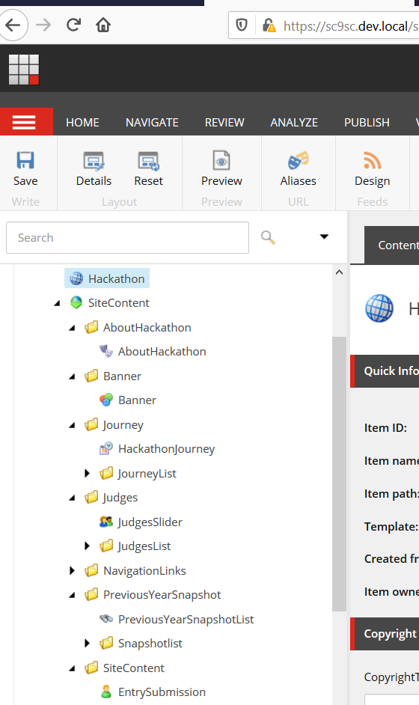

**Sitecore Form**

Site core mvc form is used for Contact us . The form is generated using Sitecore 9 forms.

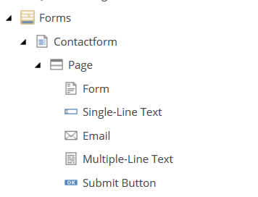

**Sitecore Renderings**

Sitecore renderings are developed under Sitecore/Renderings/Features folder .

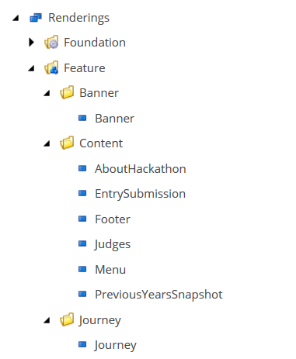

**Sitecore Media Library**

Sitecore files and images are stored in Media Library Files Hackathon folder .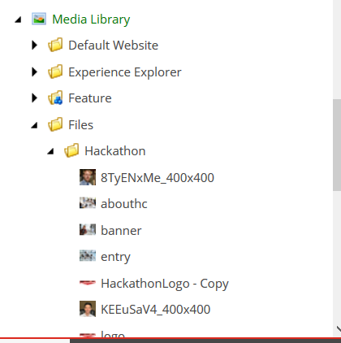

**Sitecore Template**

All the items are created from the template where base templates are stored under Sitecore / Templates/ Foundation folder .

The data templates items are created from Foundation based template and Website templates are stored over Project folder .

